**Manuals for ‘Manage Health Tips’**

**Brief of the ‘Manage Health Tips’ –** This is the page where we manage health tips.

**1. How to manage health tips-.**

Steps:

1. Login to the site and go to ‘Masters’ tab and click on ‘Manage health tips’.
2. On ‘Manage Health tips’ page, there is listing of health tips and ‘Add new health tips’ button.
3. On this page we can edit and delete the existing record.
4. For add new records click on ‘Add new health tips’ button.
5. Fill all the field and click on ‘Save’ button.
6. The added new record will display on health tips page.

1.

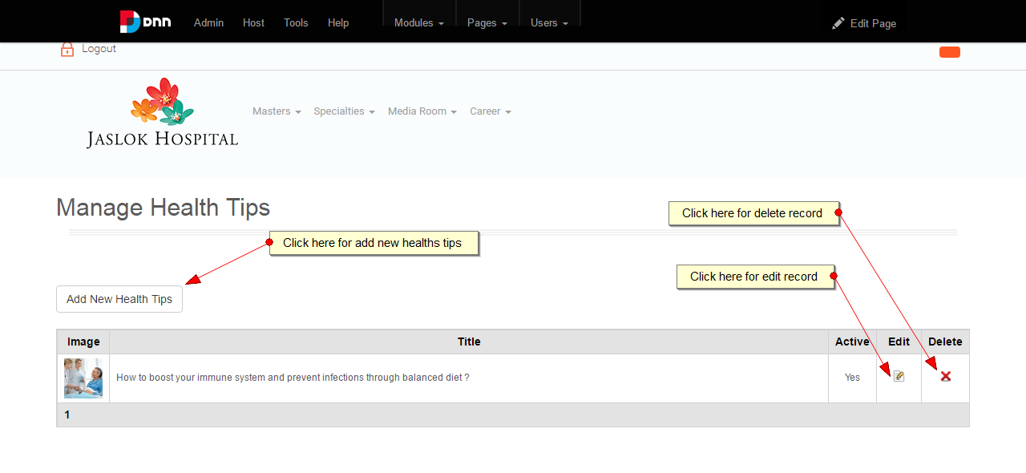

2.

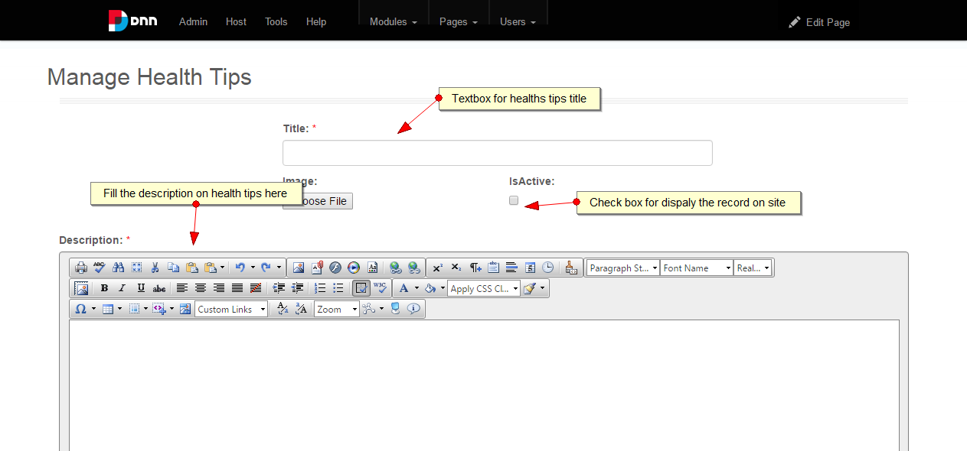

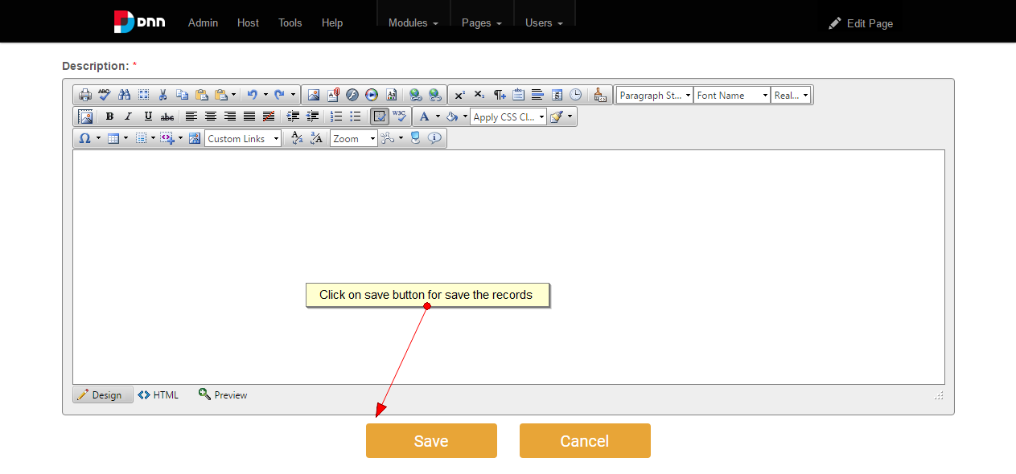

3.

